12.47: The geometry of the 3-4-5 triangle is available to simplify some of the algebra, The components of the gravitational force are

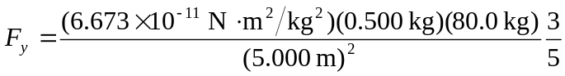

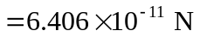

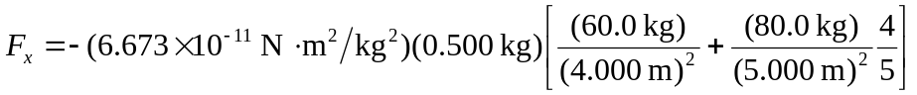

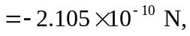

so the magnitude is 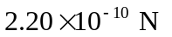and the direction of the net gravitational force is 163

